|  |  |  |  |
| --- | --- | --- | --- |
|  | |  | | --- | | YEAR 11 Essentials Mathematics 2019  Test 6 | | Total Marks: 48  Name: ______________________ Total Time: 50 minutes |   ***Full working out must be shown to get full marks. Attempt all questions in the space provided***  ***Resources allowed: 1 A4 page, (1 side) of hand written notes, ruler, calculator*** |

**Question 1**

A recent survey was conducted on people getting their drivers licenses renewed. Set A was the people getting their license renewed on Monday, while Set B were the people getting their license renewed on Tuesday.

Set A: 12, 42, 34, 76, 45, 56, 61, 73, 75, 49, 68, 51

Set B: 78, 72, 63, 68, 81, 77, 56, 77, 59, 69, 69

For each set of data above, find the following (8 Marks)

|  |  |
| --- | --- |
| Set A |  |
| mean |  |
| mode |  |
| median |  |
| range |  |

|  |  |
| --- | --- |
| Set B |  |
| mean |  |
| mode |  |
| median |  |
| range |  |

Create 5 number summaries for both set a and set b from question 1. (10 Marks)

|  |  |
| --- | --- |
| Set A |  |
|  |  |
|  |  |
|  |  |
|  |  |
|  |  |

|  |  |
| --- | --- |
| Set B |  |
|  |  |
|  |  |
|  |  |
|  |  |
|  |  |

Calculate the Interquartile range for both sets of numbers (2 Marks)

Identify any outliers using a mathematical method to demonstrate it is an outlier. (3 Marks)

Given that Set A is the ages of people renewing their drivers licenses on Monday and Set B is the ages of people renewing their driver’s license on Tuesday. Do you believe the outlier should be included in the data? Include a sentence that justifies your answer. (2 Marks)

Create parallel box and whisker plots for the 2 sets of data from part 1. (12 Marks)



Describe the similarities and differences you can see in the 2 box and whisker plots. Use at least 3 sentences. (3 marks)

**Question 2**

The following box and whisker graphs show the number of stocks (shares in the company) sold per day over a year. Answer the questions below that relate to these 3 graphs.

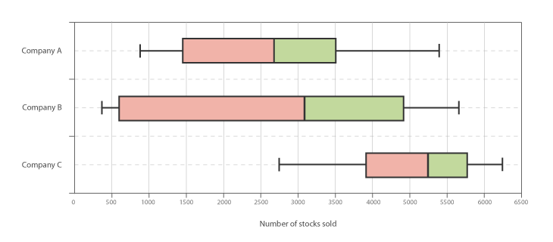

Company ________ has the highest standard deviation (1 Mark)

Company ________ has the lowest standard deviation (1 Mark)

Company _________ has the highest median. (1 Mark)

Company ___________ has the smallest interquartile range. (1 Mark)

You are told that one of the companies had over 4000 stocks sold yesterday. Which company is this most likely to be and why? (2 Marks)

Which company is most likely to have less than 3000 stocks sold on any given day? Give a sentence to explain your reasons. (2 Marks)